Data folio: poster

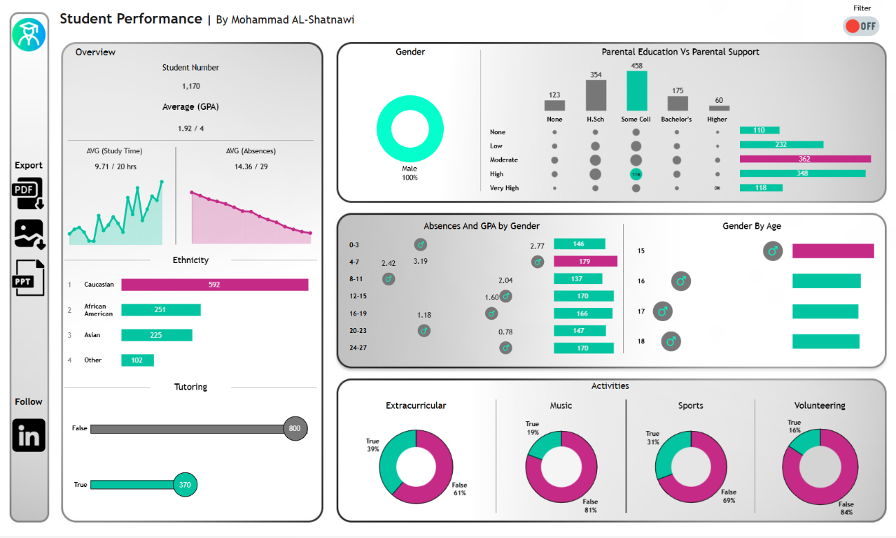Link : [Student performance Dashboard](https://public.tableau.com/app/profile/mohammad.shatnawi/viz/StudentPerformance_17392289373750/Dashboard1?publish=yes)